A guide to the best iPad revision apps
The majority of these Apps are free and you should experiment to see which you find most effective. I am not suggesting you use them all!
If you do not have an iPad or iPhone, there are useful websites listed too.
Flashcard makers - APPS
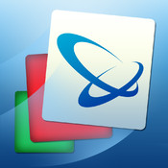 | 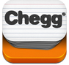
Brainscape FREE | Chegg flashcards FREE | Flashcard +FREE | Study blue

Flashcard makers - websites
www.fauxflash.com | www.flashcarddb.com
www.funnelbrain.com | www.braineos.com * recommended *
www.studystack.com | www.ediscio.com

Mind maps creators - Apps
FREE | FREE | 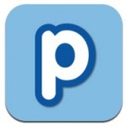  FREE | FREE
Simple mind+ | iMindmap | Popplet | Mindmeister
Mind map creator - websites
www.examtime.com | simplemapper.org

Line learning – Apps (useful for learning information for controlled assessments)
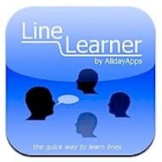
FREE

Line learner (currently listed under iphone apps in store)
With this app you can also record and listen to the information
Line learning – websites
www.cueprompter.com | www.textivate.com
GCSE Revision Apps
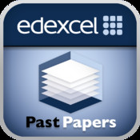  FREE | 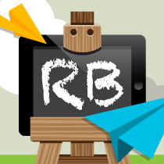  FREE | 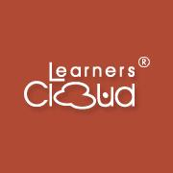  FREE
Edexcel past papers  Practise past papers for a wide range of subjects | Revision Buddies  Available for French, History and R.E | Learnerscloud Revision questions  Available for Chemistry, English, Maths and Physics
FREE | 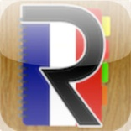  £1.49 each
Learnerscloud Revision Videos  Available for Chemistry, Maths, English, Biology and Physics. | ieducation  Available for GCSE Business, Maths, English Lit, P.E, Geography, French, History, German and Spanish
iPad Apps for learning Modern Foreign Languages

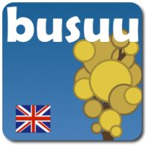  FREE | 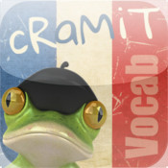  £1.49 | 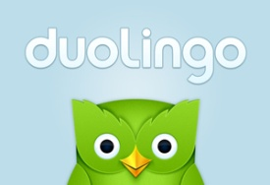  FREE
Busuu  Available for French, German and Spanish. | cRaMit  French, German and Spanish. | Duolingo  French, German and Spanish
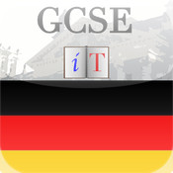  £1.49 | 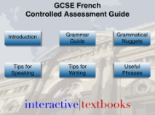  £1.49 | 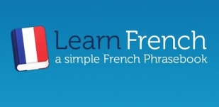  FREE
Iain Coleman GCSE  French and German | Controlled assessment GCSE  French and German | Learn (French/German/Spanish) Phrasebook
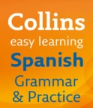  FREE | 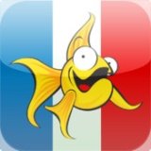  £2.99 | 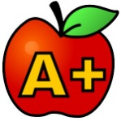  FREE
Collins easy learning  Grammar and Practice available for French and Spanish. | Linguascope vocabulary trainer  Available for French, Spanish and German. | A+TestYou Foreign Languages  Basic vocabulary revision for many languages.

TWITTER
There are some great resources on twitter to help you practise and expand your vocabulary. Here are some of the best.

GERMAN
German should be fun @LearnXDGerman German phrases followed shortly after by the English translation.
Jabba German @JabbaGerman Daily German words, phrases and games
DW learn german @dw-learngerman
Learn 10 German @learn10german
Learn German @MyLinguaDE

FRENCH
French Today @frenchToday
Radio Lingua French @learnfrench
Learn 10 French @learn10french
Learn French today @french_learner

SPANISH
Liv Lang Spanish @LL_Spanish Daily Spanish words and phrases
Radio Lingua Spanish @learnspanish Daily quizzes
Learn 10 Spanish @learn10spanish Regular vocabulary
Learn Spanish @WoodwardSpanish

JAPANESE
Learn Japanese Pod @japanesepodcast

BUSINESS STUDIES
Business Studies @DHSBusiness Exam tips, techniques and business related information
Tutor2u Business @tutor2ubusiness Free resources to help you revise
Business Studies @KingEdBiz

